**AI Project 1 Report**

0516076施威綸

**Tests**

* **Brute force (node consistent)**

I did not know how long would it take to finish.

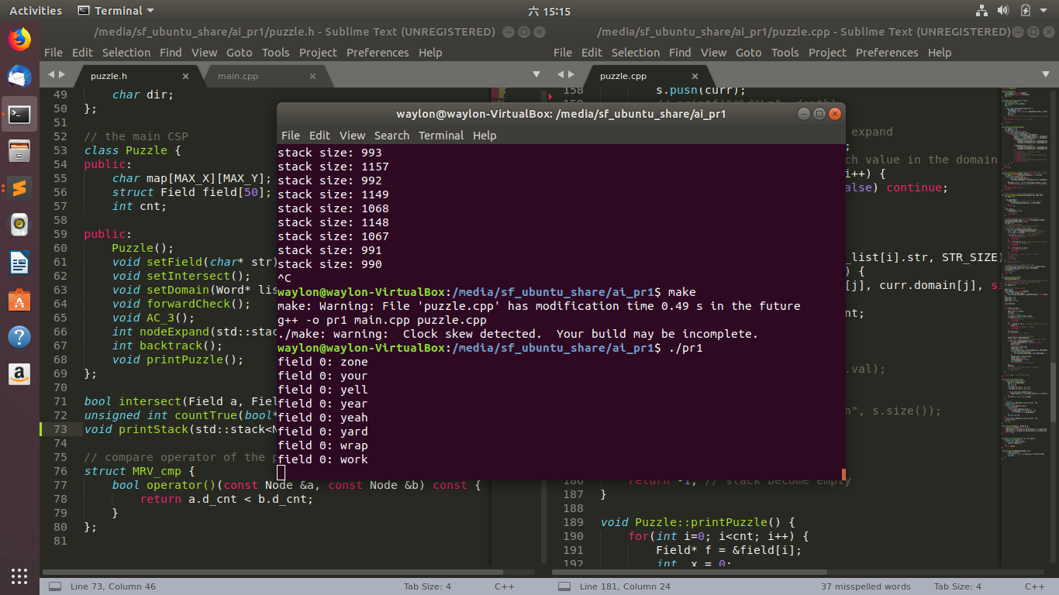

The time complexity is O(bn), where the branching factor here is 500 approximately, the time to complete searching is all by luck.

So I created a smaller word list (domain) to ensure the code works properly.

* **MRV/LCV**

The program consumes more time in most cases in this method.

More nodes are visited.

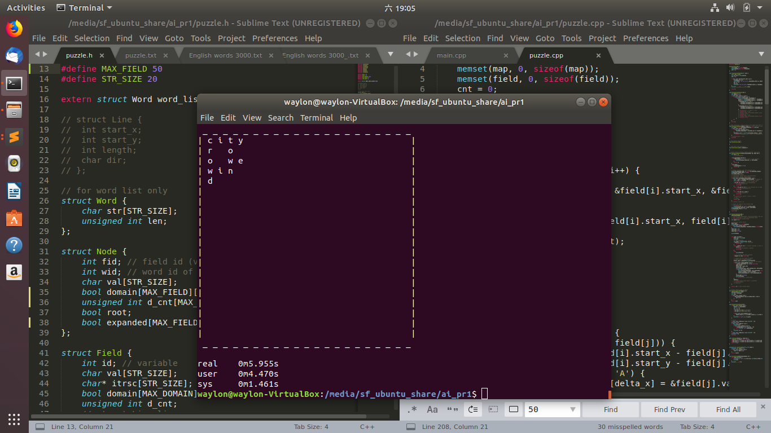

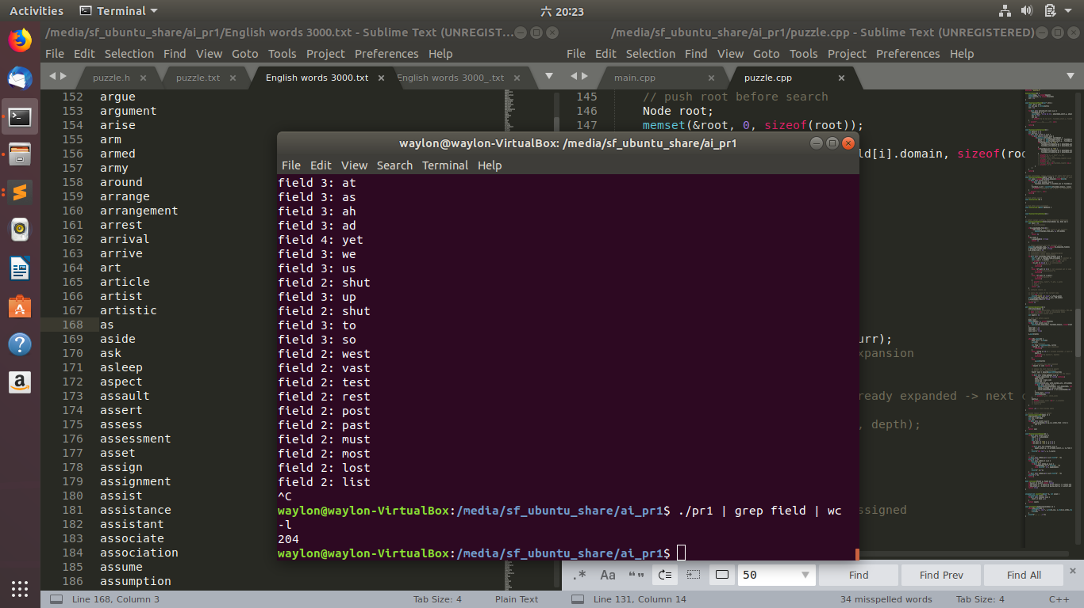 visited nodes

* **AC-3 & forward checking**

Not yet finished.

I had tried AC-3 before searching, but failed.

I have not figured out when to update the neighbors, which is the main cause of failure.

**Discussion**

At first, I did not realize that each node stands for a state. So I encountered a lot of difficulties.

The 4th puzzle are not solved in the end, while the program had run more than an hour.

The depth of the last puzzle is 12. Compare to the previous ones (5~6), the time may be 5006(up) longer.

* **Observation**

Forward checking and arc consistency will reduce the branching factor and may be critical to improve performance. (number of values in domain has reduced)

* **Remaining problem**

To finish forward checking.

**Appendix**

main.c + puzzle.h (1)

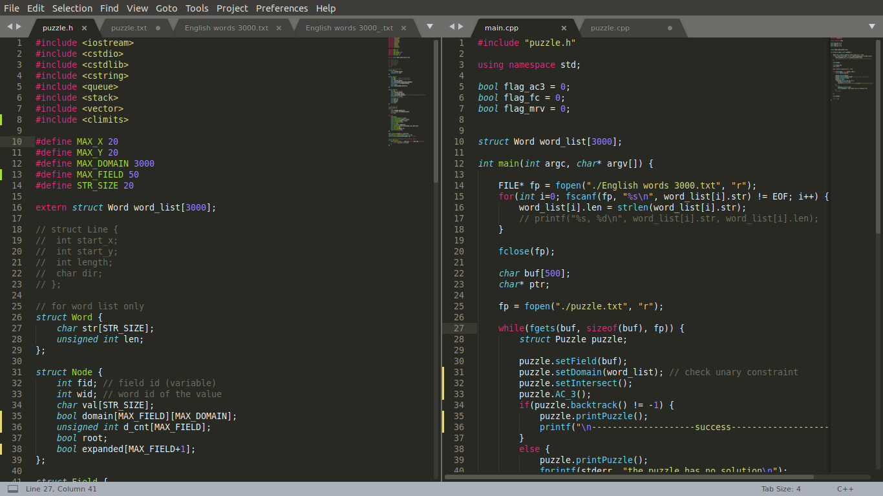

main.c + puzzle.h (2)

